 | Autumn 1 | Spring 1 | Summer 1
Year 3 | Painting and Mixed Media:  Prehistoric Painting  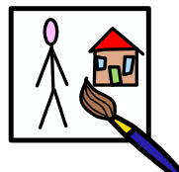 | Sculpture and 3D:  Abstract space and shape  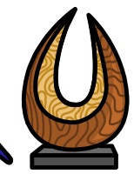 | Drawing:  Growing artists  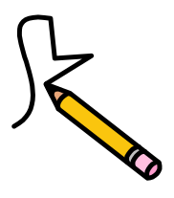
Year 4 | Sculpture and 3D:  Mega Materials | Drawing:  Exploring tone, texture and proportion | Painting and Mixed Media:  Light and Dark
Year 5 | Drawing:  Depth, emotion and movement | Painting and mixed media:  Portraits | Sculpture and 3D:  Interactive Installation
Year 6 | Drawing:  Expressing my ideas | Painting and Mixed Media:  Artist study | Sculpture and 3D:  Making memories
Art Overview

